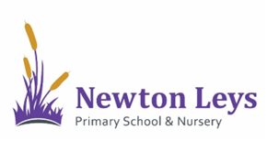
Newton Leys Primary School & Nursery
San Andres Drive
Newton Leys
Milton Keynes
MK3 5GG

Tel: 01908 630253
Email: office@newtonleysprimary.org
www.newtonleys primary.org

Dear Parents/Carers,

In the past week, your child has been learning these sounds in their daily phonics session:

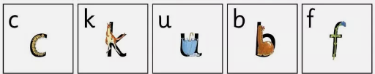

Here at Newton Leys Primary School, we teach phonics through the scheme Read, Write, Inc. We are fortunate enough to have use of the Read, Write, Inc Virtual Portal which allows us access to teaching videos amongst some other amazing resources! Each video will introduce a sound and give your child an opportunity to practice reading this sound and spot it in words at home.

All you need to do is hover your camera or a QR Code app over each QR Code (below) and it will provide you with a link for each video. These videos are just over 10 minutes long and your child will be able to participate in them independently.

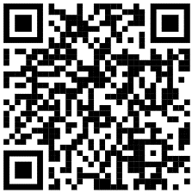  c | 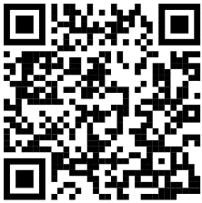  k | 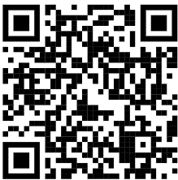  u
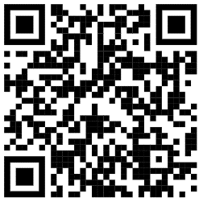  b | 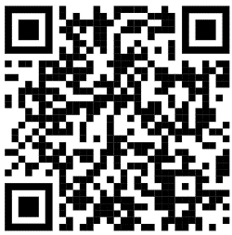  f

We will be sharing new videos every week and hope you find them beneficial. If you have any questions, please do not hesitate to contact me.

Kind Regards,

Mrs Moore
Phonics Lead

